**PHASE 5 – Final documentation**

**WORKS OF PHASE 1**

**SMART WATER SYSTEM - USING IOT**

**Problem Definition:**

1. **Project Scope and Objectives:**
   * The scope of our project is to implement an IoT-based smart water system in public parks to minimise water wastage.
   * Objectives: To provide real-time water consumption and utilization data to park visitors, ensuring sustainable water consumption and minimal/zero wastage.
2. **Data Collection and Parameters:**
   * Data to be collected : water consumption and utilization in toilets, drinking water facilities and irrigation systems.
   * Parameters to be identified: Water flow rate in taps and sprinklers, water tank level and filling pace.
3. **Environmental Challenges:**
   * Address the issue of water wastage in public places such as parks is highly prevalent.
   * Highlight the necessity of conveying data to park users to promote water conservation awareness and responsibility.

**Design Thinking:**

1. **IoT Device Selection and Deployment:**
   * Select appropriate sensors for water flow rate and water level indication.
     + Water flow rate – velocity/pressure sensors
     + Water level indication – ultrasound sensors

* + Plan the deployment of these sensors in appropriate locations for accurate data collection.

1. **Platform Development:**
   * Design a user-friendly web-based platform accessible to park visitors.
   * Implement real-time data visualization and display for water level and consumption status.
2. **Data Integration and Communication:**
   * Determine the communication protocol (e.g., Wi-Fi, LoRaWAN) for data transmission from IoT devices to the platform.
   * Develop a backend system for data processing and integration with the platform.
3. **Power Supply and Maintenance:**
   * Choose suitable power supply options (e.g., batteries or solar panels) for IoT sensors.
   * Outline maintenance procedures to ensure continuous operation.
4. **User Engagement and Safety:**
   * Implement an alert system to notify users of high water consumption.
   * Focus on user training and support to ensure effective utilization of the monitoring platform.
5. **Documentation and Reporting:**
   * Maintain comprehensive project documentation, including system architecture and user guides.
   * Provide periodic reports on water data and system performance to park management and the public.

Thus, this project facilitates the monitoring of water usage in public places such as parks using IoT system and displays and alerts the users with the collected data to ensure minimal/zero water wastage in the park.

**WORKS OF PHASE 2**

**SMART WATER SYSTEM - USING IOT**

* This IOT project is aimed to promote sustainable water consumption and conservation strategies in public parks.
* **Overall design plan:**
* **Sensor and components:**
  + - Velocity/pressure sensors shall be placed in the pipeline network housing the tap-water system and irrigation system of park flora to measure the water flow rate.
    - Ultrasound sensors shall be positioned on water tanks to check water levels during different times of the day.
    - Other data such as weather information and soil moisture etc. are collected as per needs.
* **Data analysis:**
  + - Water flow rate can be used to determine the volume of water utilised for drinking, washroom purposes and irrigation.
    - By checking the water levels of tanks, the number of refills over a period of time can be determined.
    - Microprocessors such as ESP-32 and Raspberry-Pi as to be used.
* **Data interfacing and display:**
  + - By implementing Machine Learning Algorithms , analysed data can be effectively interfaced for the user’s benefit to view a detailed depiction of water consumption in parks.
    - Mobile App:
    - To create a user-friendly mobile app for park managers, maintenance staff, and the general public.
    - Users can access real-time water consumption data, receive alerts, and report issues like leaks or water quality concerns.
    - Dashboard:
    - To develop a web-based dashboard for park management to monitor water usage, system health, and predictive analytics.
    - It provides insights into water conservation efforts and cost savings.
* **Machine Learning Algorithm deployment:**
* **Purpose in IOT system:** 
  + - Predictive Analytics:
    - To utilize machine learning algorithms to predict water demand based on historical data, weather forecasts, and park foot traffic patterns.
    - These predictions can help optimize water supply in advance, preventing wastage.
    - Anomaly Detection:
    - To implement anomaly detection algorithms to identify water leaks, pipe bursts, or abnormal water usage patterns in real-time.
    - If an anomaly is detected, the system can trigger alerts for immediate action.
    - Irrigation Optimization:
    - To employ machine learning to optimize park irrigation schedules based on soil moisture levels, weather forecasts, and plant types.
    - The system can automatically adjust irrigation frequency and duration to conserve water while maintaining healthy green spaces.
    - Public Toilet Usage Prediction:
    - To analyze historical data to predict peak hours of public toilet usage.
    - This allows for efficient maintenance and cleaning schedules, reducing water consumption while ensuring restroom hygiene.
* **Some ML Techniques to be used:**
  + - Random Forest Algorithm:
    - Random Forest is an ensemble learning technique in machine learning.
    - It combines multiple decision trees, each trained on a random subset of the data and a random subset of features.
    - This randomness reduces overfitting, improves model accuracy, and provides feature importance scores for better understanding of factors influencing predictions.
    - It is widely used for classification and regression tasks and excels at handling diverse data types.
    - Decision Trees and Random Forests can classify factors influencing water usage in public parks and toilets by identifying key features, such as weather conditions, visitor density, and time of day, that impact water consumption.
    - This model helps create decision rules to analyze and categorize these factors, aiding in understanding and optimizing water management strategies.
    - ARIMA Algorithm:
    - ARIMA, or AutoRegressive Integrated Moving Average, is a time series analysis and forecasting method that models and predicts how a variable changes over time.
    - It consists of three components: AutoRegressive (AR) for past values, Integrated (I) for differencing to achieve stationarity, and Moving Average (MA) for random fluctuations.
    - The model is expressed as ARIMA(p, d, q), where "p" represents past values, "d" is the number of differencing steps, and "q" is the order of moving averages.
    - ARIMA is used to preprocess data, identify the model's parameters, fit the model, make predictions, and assess forecast accuracy.
    - It is well-suited for data with temporal patterns, making it applicable to water consumption analysis where historical usage patterns change over time.
    - ARIMA can capture seasonality and trends in water consumption, making it useful for short to medium-term predictions.
    - Its parameters (p, d, q) are tuned to optimize model performance, and it is often used for univariate time series data.
* **Water Conservation strategies :**

This project aims to develop conservation strategies as follows:

* **Smart Valve Control:** 
  + - To install smart valves and actuators that can be remotely controlled and programmed based on the recommendations from the machine learning algorithms.
    - Valves can be shut off during rainy periods or when anomalies are detected.
* **Water Quality Control:** 
  + - To integrate water quality sensors in public toilets to monitor water cleanliness.
    - If the water quality degrades, the system can automatically shut off the supply, preventing contamination.
* **Remote Maintenance:** 
  + - To Enable remote diagnostics and maintenance of the entire system to reduce downtime and ensure optimal performance.
    - Also, to alert and notify to replace older and less water-efficient fixtures with low-flow toilets, faucets, and showerheads in park restrooms and facilities.
* **Leak Detection and Repair:**
  + - To detect leaks in the park's water infrastructure promptly and repair any leaks as soon as they are identified to prevent water wastage.
* **Irrigation Optimization:**
  + - To adjust the park's irrigation schedule based on real-time data from the monitoring system.
    - To implement smart irrigation systems that can adjust water flow based on weather conditions and soil moisture levels.
* **Scheduled Watering:**
  + - To set specific hours for watering the park's landscaping to reduce evaporation losses.
* **Xeriscaping Practices:**
  + - To incorporate xeriscaping principles in park design, focusing on minimal water use and sustainable landscaping practices.
* **Community Involvement:**
  + - To engage the local community in park conservation efforts by providing real-time data.
    - To promote awareness on minimal water usage and sustainable water conservation by highlighting factual data.
* **Benefits:**
* Efficient water usage leading to significant water conservation.
* Reduced water costs for park management.
* Improved green space health due to optimized irrigation.
* Enhanced restroom hygiene in public toilets.
* Quick detection and mitigation of water leaks and anomalies.
* Data-driven decision-making for park management.
* Public engagement in water conservation efforts.

Implementing such an innovative smart water management system not only contributes to environmental sustainability but also enhances the overall experience of park visitors and reduces operational costs for park management.

**WORK OF PHASE 3**

**SMART WATER SYSTEM**

PROJECT DESCRIPTION:

For the monitoring of water tanks used to supply water for drinking, irrigation, restrooms and cleaning, ultrasonics are placed at the top of the tanks. This sensor will send ultrasonic waves which would hit the surface of the water and get reflected back. Depending on the time taken to reflect back from the water level the ultrasound calculates the water level.

Here, the ultrasound in interfaced with Raspberri Pi Pico microcontroller. Four LEDs are connected as well as a relay for motor is connected.When the sensor detects the distance travelled by the reflected wave is greater than 400 cm, green LED glows and motor relay is switched on, indicating that the water level in the tank is low. When the distance is between 200 cm and 400 cm,yellow LED glows indicating water level s the middle range. When the distance is less than 100 cm, red LED glows, indicating the high water level in tank.

SCREENSHOTS:

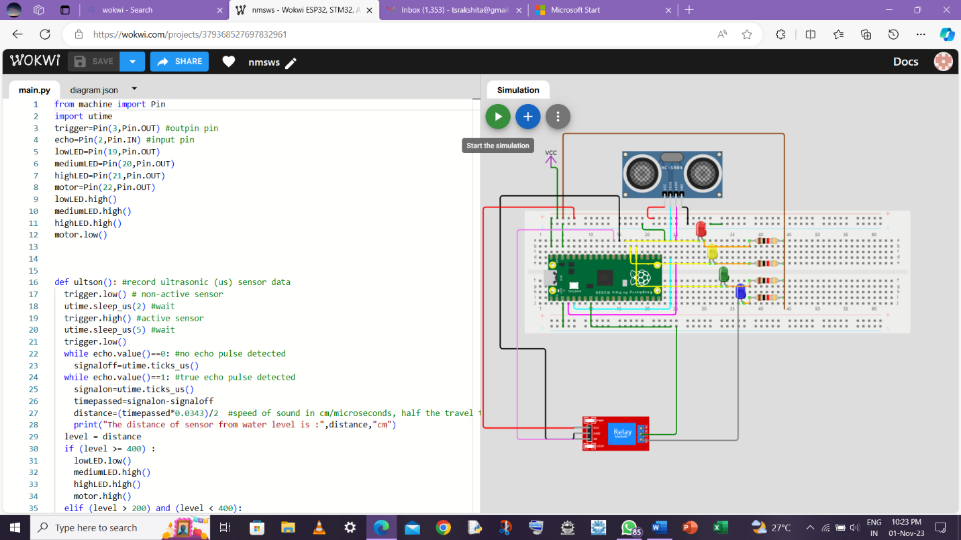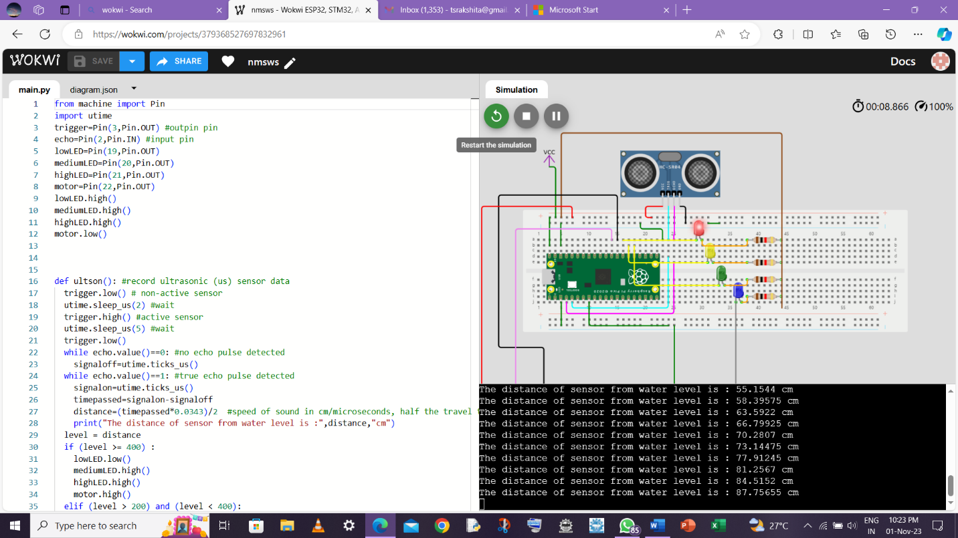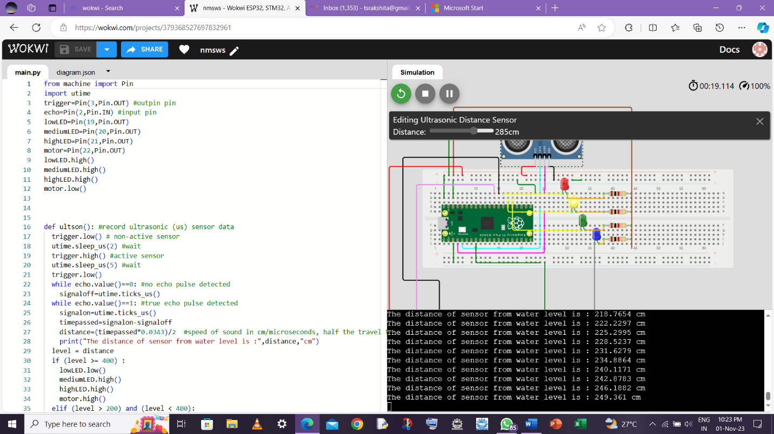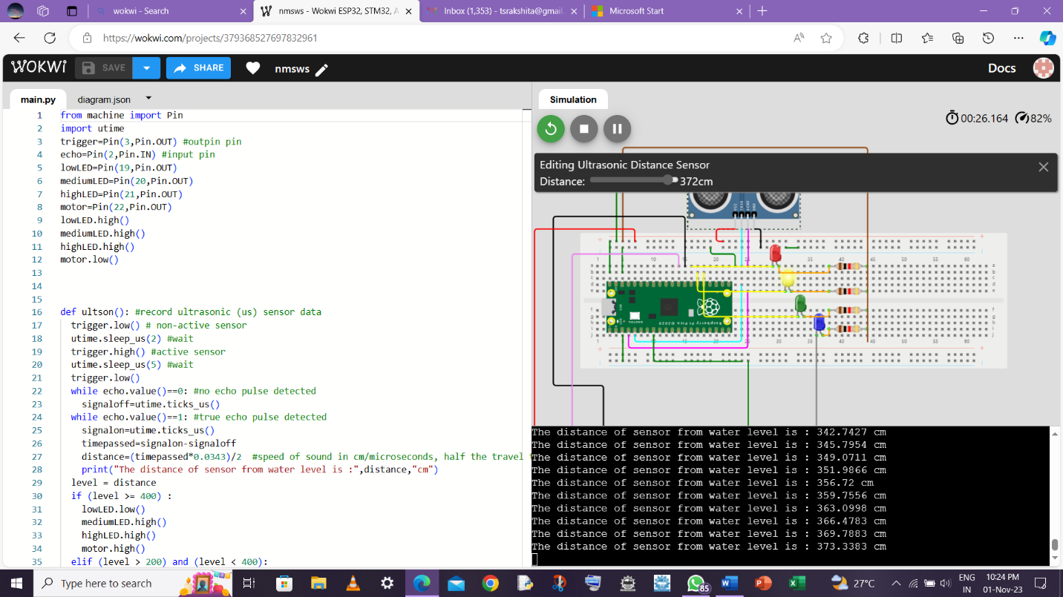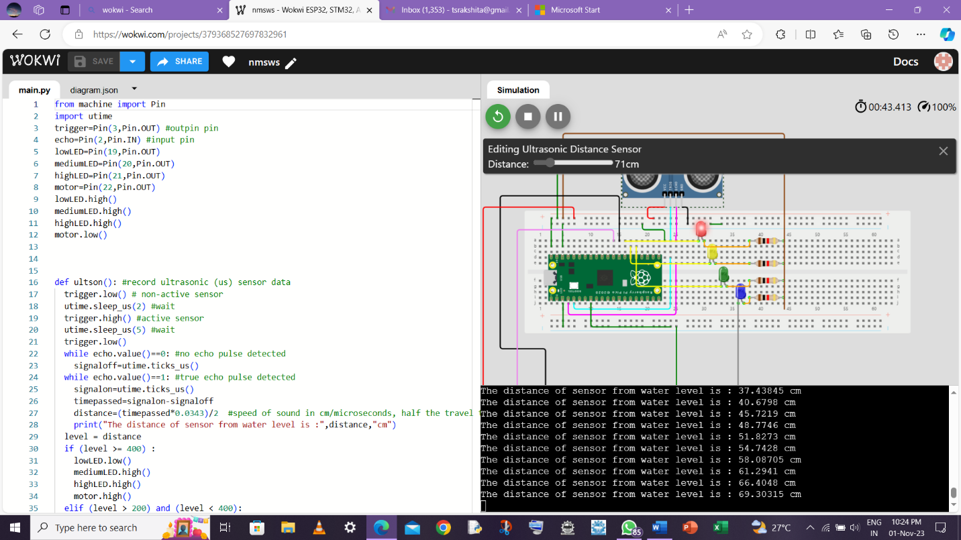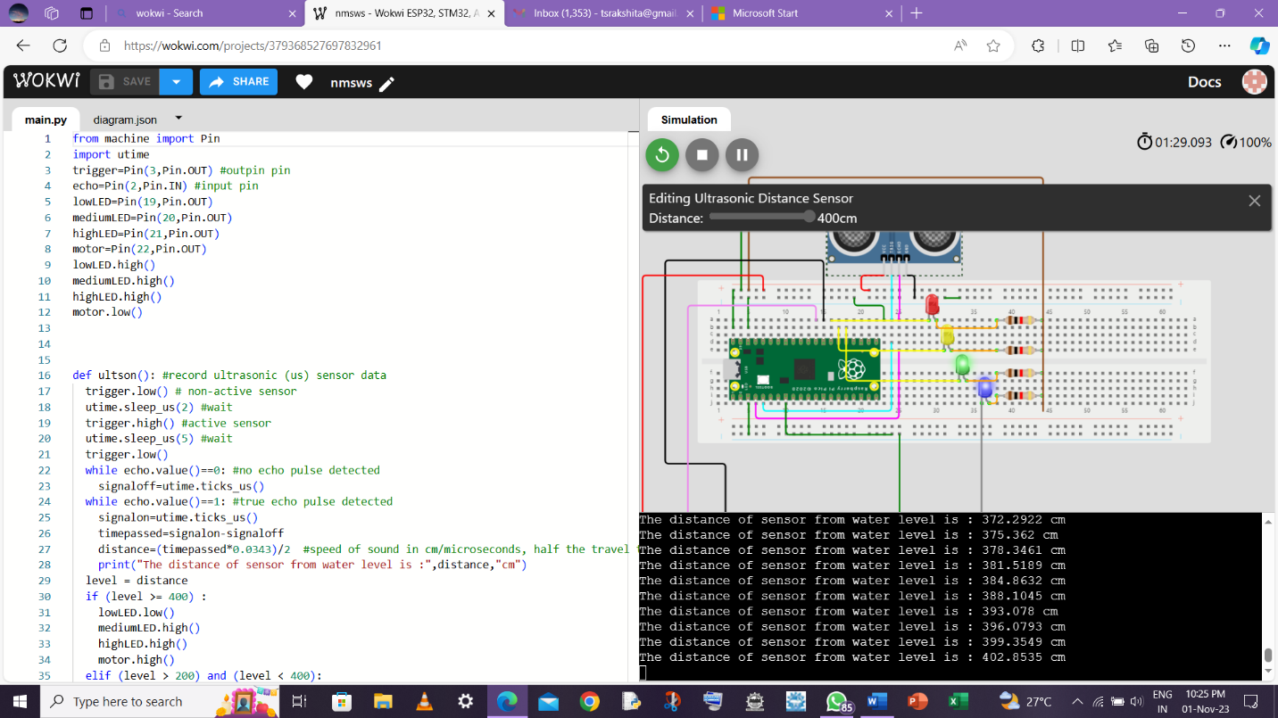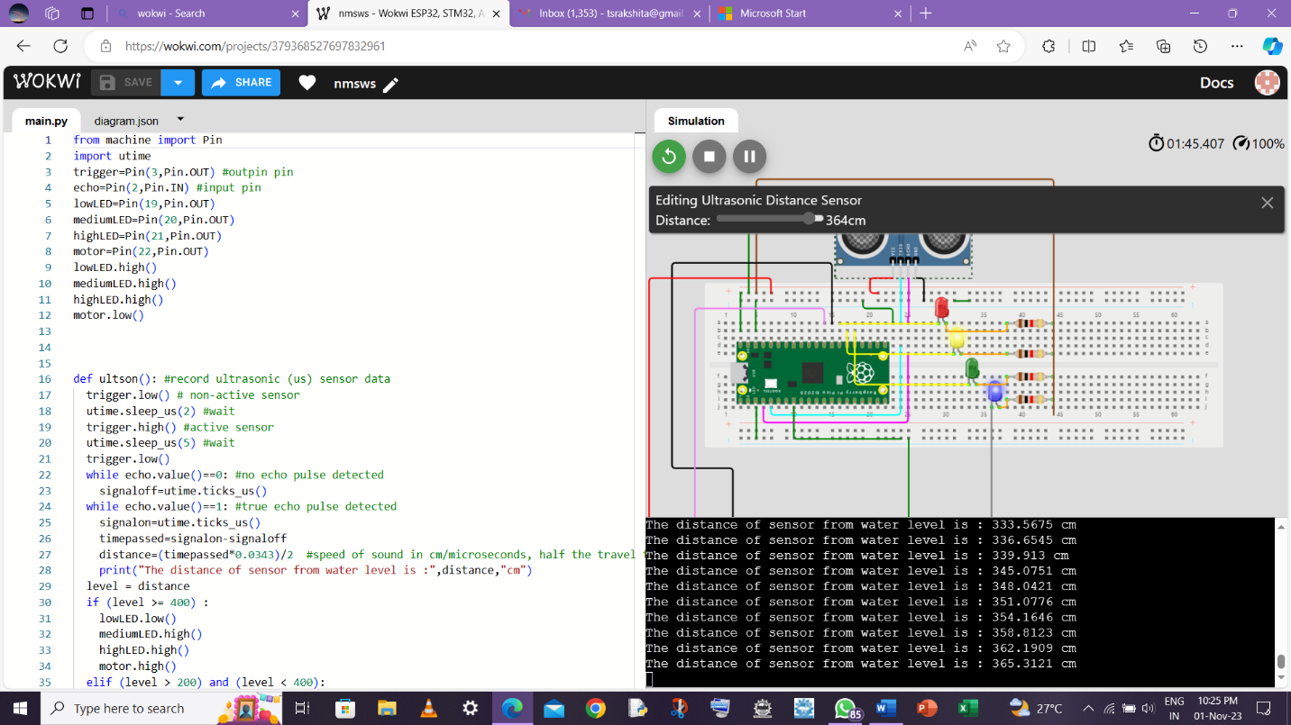

MICROPYTHON CODE:

from machine import Pin

import utime

trigger=Pin(3,Pin.OUT) #outpin pin

echo=Pin(2,Pin.IN) #input pin

lowLED=Pin(19,Pin.OUT)

mediumLED=Pin(20,Pin.OUT)

highLED=Pin(21,Pin.OUT)

motor=Pin(22,Pin.OUT)

lowLED.high()

mediumLED.high()

highLED.high()

motor.low()

def ultson(): #record ultrasonic (us) sensor data

  trigger.low() # non-active sensor

  utime.sleep_us(2) #wait

  trigger.high() #active sensor

  utime.sleep_us(5) #wait

  trigger.low()

  while echo.value()==0: #no echo pulse detected

    signaloff=utime.ticks_us()

  while echo.value()==1: #true echo pulse detected

    signalon=utime.ticks_us()

    timepassed=signalon-signaloff

    distance=(timepassed*0.0343)/2  #speed of sound in cm/microseconds, half the travel time

    print("The distance of sensor from water level is :",distance,"cm")

  level = distance

  if (level >= 400) :

    lowLED.low()

    mediumLED.high()

    highLED.high()

    motor.high()

  elif (level > 200) and (level < 400):

    lowLED.high()

    mediumLED.low()

    highLED.high()

  elif (level < 100):

    lowLED.high()

    mediumLED.high()

    highLED.low()

    motor.low()

while True:

  ultson()

  utime.sleep(5)

**WORK FOR PHASE 4**

**SMART WATER SYSTEM**

**Description**

In this project, we’ve used Google Firebase to code for Smart water management System.

* To set up a console in Google Firebase we first sign in and create a new project.
* Enter the Project Name and Project ID.
* From Project Dashboard choose Database.
* Create a Real-time Database and choose start in test mode.
* Now copy your Firebase Project URL and Paste the URL in Code at FIREBASE_HOST without “https://” and “/”.
* Now go to Settings (near project overview on the dashboard).
* Choose Project Settings > Service Account > Database Secrets.
* Copy Project Secret than Paste in code at FIREBASE_AUTH.

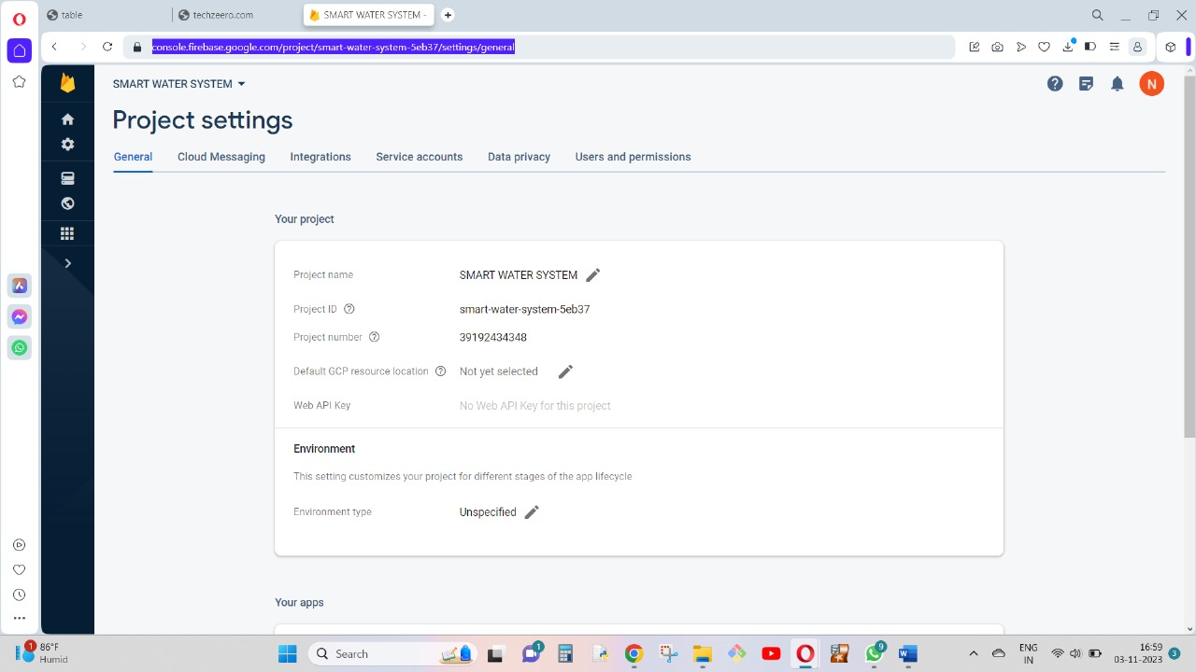

**Firebase Code for Our Smart Water System Project**

import urequests

import utime

from machine import Pin

trigger = Pin(3, Pin.OUT)

echo = Pin(2, Pin.IN)

lowLED = Pin(19, Pin.OUT)

mediumLED = Pin(20, Pin.OUT)

highLED = Pin(21, Pin.OUT)

motor = Pin(22, Pin.OUT)

lowLED.high()

mediumLED.high()

highLED.high()

motor.low()

FIREBASE_URL = smart-water-system-5eb37-default-rtdb.firebaseio.com

FIREBASE_SECRET = S7fEfnpPBJIE1TPgjJOFRabNn1ztM3yJJGdHuIE1

def ultson():

trigger.low()

utime.sleep_us(2)

trigger.high()

utime.sleep_us(5)

trigger.low()

while echo.value() == 0:

signaloff = utime.ticks_us()

while echo.value() == 1:

signalon = utime.ticks_us()

timepassed = signalon - signaloff

distance = (timepassed * 0.0343) / 2

print("The distance of sensor from water level is:", distance, "cm")

level = distance

if level >= 400:

lowLED.low()

mediumLED.high()

highLED.high()

motor.high()

elif 200 < level < 400:

lowLED.high()

mediumLED.low()

highLED.high()

elif level < 100:

lowLED.high()

mediumLED.high()

highLED.low()

motor.low()

# Send data to Firebase

data = {

"distance_cm": distance,

"level": level,

}

# Construct the Firebase URL

firebase_url = f'{FIREBASE_URL}.json?auth={FIREBASE_SECRET}'

# Send data to Firebase

response = urequests.put(firebase_url, json=data)

if response.status_code == 200:

print("Data sent to Firebase successfully")

else:

print("Failed to send data to Firebase")

while True:

ultson()

utime.sleep(5)

**Description**

FIREBASE_URL = smart-water-system-5eb37-default-rtdb.firebaseio.com

FIREBASE_SECRET = S7fEfnpPBJIE1TPgjJOFRabNn1ztM3yJJGdHuIE1

**Android App Setup Using MIT App Inventor**

**Steps :**

* Sign in [**MIT App Inventor**](http://ai2.appinventor.mit.edu/) and import .aia file from the downloaded file.
* Open the Project and Choose FirebaseDB1 from the Components list.
* In properties Paste Firebase Projects Secret in “Firebase Token” and Firebase Project URL in “FirebaseURL”.
* Paste full URL along with “https://”.
* Project Bucket should be empty.

**Screenshots:**

MIT App Inventors developing workspace.

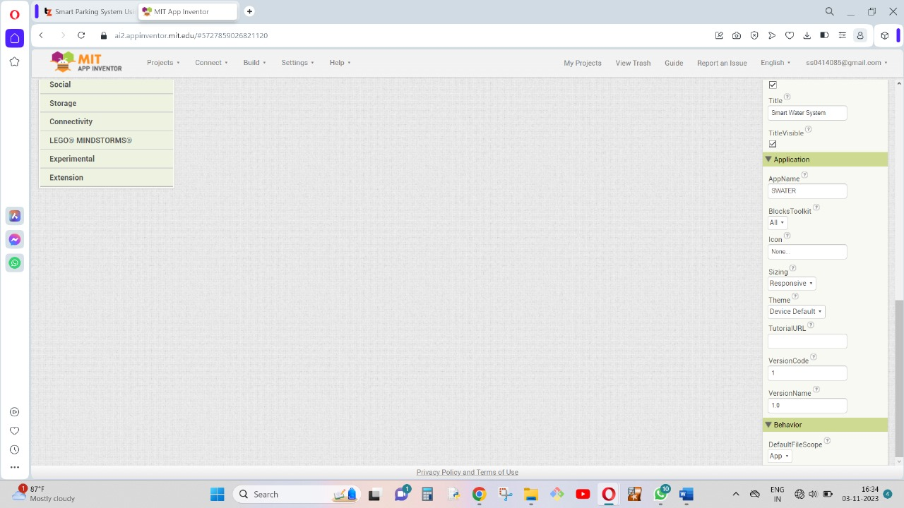

* The Smart Water System App interfacing screen is displayed in this picture.
* 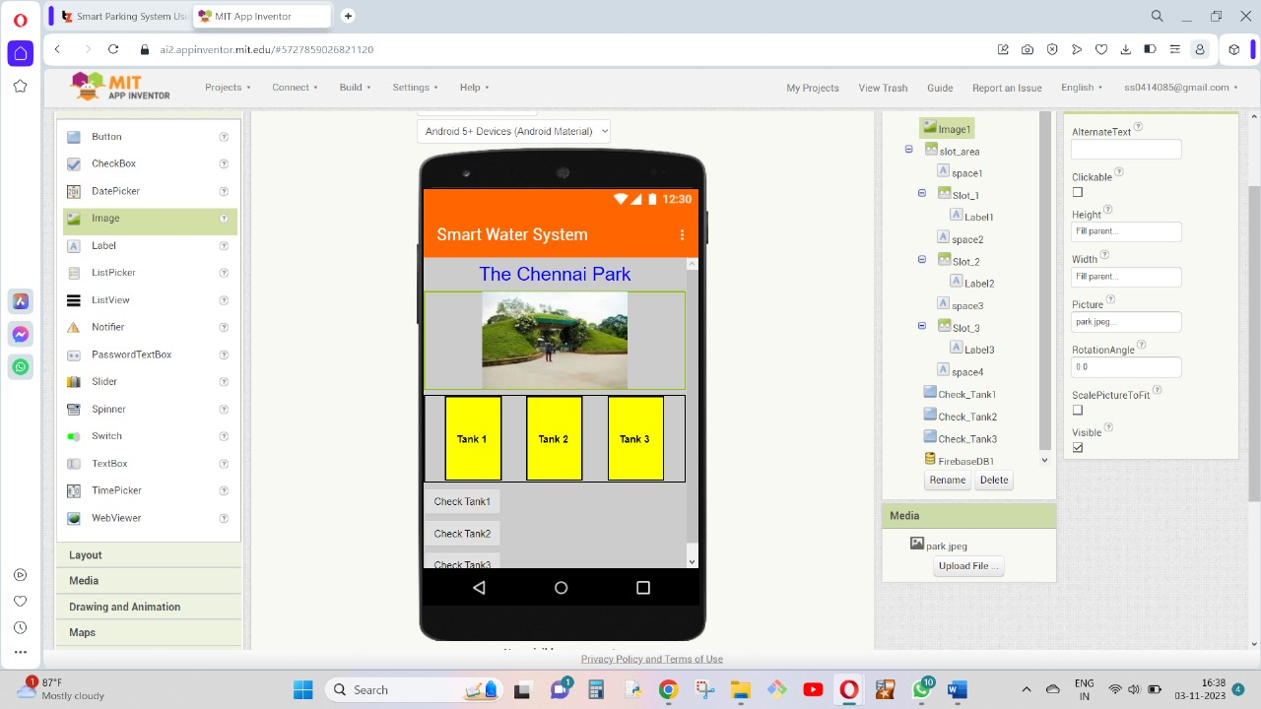The tanks in the display show the level of water and monitor it through water sensors and Information data that is transferred.
* 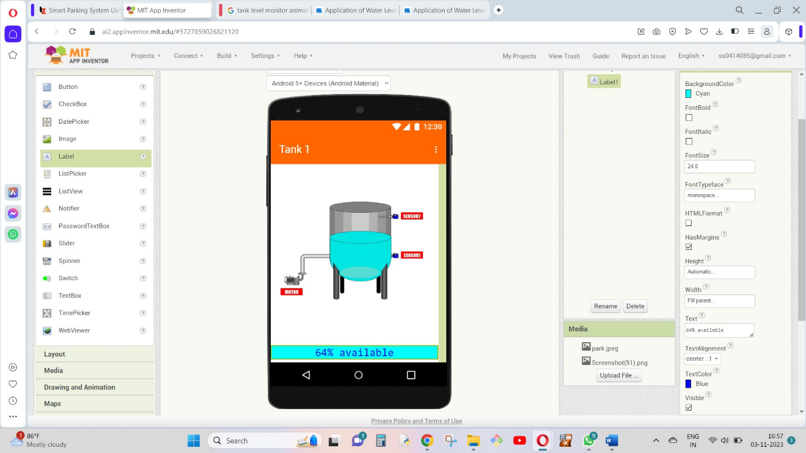****The Tank buttons show the level of water present in real-time to the users of the app.
* In this picture , Water level in Tank 1 is observed as 64%. There are 2 sensors present in the tank below. Sensor 1 will detect whether the water is present in the tank and the Sensor 2 will detect the tank is full of water.

**CONSERVATION STRATERGY OF WATER IN PARKS:**

* Xeriscaping: Use xeriscaping techniques to design and maintain park landscapes. Plant drought-tolerant native species that require less water, and group plants with similar water needs together.
* Irrigation Management: Implement efficient irrigation systems with smart controllers that adjust watering schedules based on weather conditions and soil moisture levels. Use drip irrigation or soaker hoses to minimize water waste.
* Mulching: Apply a layer of mulch around trees and plants to reduce evaporation, control weeds, and maintain soil moisture.
* Rainwater Harvesting: Install rain barrels or cisterns to collect rainwater for irrigation. This can be used to supplement park watering needs.
* Greywater Reuse: Use treated greywater from restrooms or other sources for irrigation, provided local regulations permit this practice.
* Water-Efficient Fixtures: Replace old, inefficient restroom and maintenance facility fixtures with water-saving versions, such as low-flow toilets, urinals, and faucets.
* Water Recycling: Consider installing water recycling systems to treat and reuse water from fountains, pools, or other water features.
* Drought Contingency Plan: Develop a plan for responding to drought conditions, which includes adjusting watering schedules, prioritizing water use, and communicating with the public.
* Public Education: Raise awareness among park visitors about the importance of water conservation and encourage responsible water use.
* Regular Maintenance: Ensure that irrigation systems are well-maintained, with regular checks for leaks, clogs, and broken components.
* Native Landscaping: Design parks with native plants that are adapted to the local climate and require minimal water. These plants are typically more resilient and need less maintenance.
* Monitoring and Data Analysis: Use technology and data collection to monitor water use and identify opportunities for optimization. Make adjustments based on the results.
* Sustainable Turf Management: Reduce the size of turf areas and use grass species that require less water. Implement proper turf maintenance practices like aeration and over seeding.
* Water-Saving Technology: Explore advanced technologies such as soil moisture sensors and weather-based controllers to optimize irrigation.
* Water-Conserving Infrastructure: Incorporate water retention ponds and permeable pavements to capture and store rainwater, reducing the need for irrigation.
* Volunteer and Community Engagement: Engage local communities in park maintenance and water conservation efforts. Encourage community involvement in taking care of the park.
* Water Conservation Policies: Ensure that the park's management has clear policies in place for water conservation and adheres to relevant regulations and guidelines.

**CONCLUSION**

Conserving water in parks is essential to maintain green spaces, preserve natural ecosystems, and ensure sustainable use of this valuable resource. We are developing IOT based system to conserve energy in public places such as parks. By implementing our smart water system, parks can reduce their environmental impact, lower water bills, and contribute to the sustainable use of water resources while still providing enjoyable green spaces for the community.